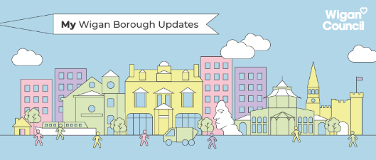
Covid-19 updates September 20th with GMCA updates
The borough’s number of new cases has seen a further increase.

View the full tracker here
https://www.wigan.gov.uk/Docs/PDF/Resident/Crime-Emergencies/COVID19-Weekly-Tracker.pdf

The council has started its management plans to mitigate the situation as part of wider efforts across Greater Manchester and the region.
It is still very important for residents to follow the public health guidance around face coverings, washing hands regularly and social distancing.

The national restrictions on gatherings are now in place. It means groups of more than six people are not able to meet, indoors or outdoors.
The guidance previously allowed gatherings of up to 30 people. This number will be reduced to six people from today.
There are some exceptions, including funerals and weddings.

New Covid-19 restrictions in the North West
Stricter restrictions will be implemented in parts of the North West, Midlands and Yorkshire from next week. The new measures have been confirmed by the Department for Health following consultation with local leaders.
Lancashire, Merseyside, Warrington, and Halton have been escalated to areas of intervention, and fresh restrictions will come into force in Wolverhampton, Oadby & Wigston, and parts of Bradford, Kirklees and Calderdale.
Regulations and guidance differ between the areas, but all are due to come into force from Tuesday

More information can be found here
https://www.gov.uk/government/publications/coronavirus-covid-19-meeting-with-others-safely-social-distancing/coronavirus-covid-19-meeting-with-others-safely-social-distancing

Chapel Lane test centre
Due to shortages within the national testing system and the knock-on impact on locally run centres, the decision has been made to close Chapel Lane to new bookings.
Chapel Lane is locally run and is not part of the national system.
This situation will be kept under review while a backlog of appointments take place and the national testing situation eases. We will keep you informed of any updates.
In the meantime, residents with Covid-19 symptoms are advised to check test availability via the government website.

More information here
https://www.gov.uk/get-coronavirus-test

Like most of the country, the borough has seen a rise in covid-19 infections as schools return, more venues open and many residents go back to work.
The borough is now reporting more than 50 cases per 100,000 people and has therefore passed the threshold to red status.
It’s vital we remind residents to not get complacent, so we don’t see infection rates rapidly rising and even tighter restrictions put in place. We’ll be reminding residents to be wear face coverings, wash their hands regularly and to watch their distance as part of our escalation campaign. The following is a statement issued earlier this week from the Leader of the Council:

The Fire Within relaunch
This Saturday 19 September, we will open the next phase of our cultural manifesto, The Fire Within, with a new show focused on promoting social inclusion.
The theme for 2020/21 is Digital Wigan and the title of the exhibition – We Will Always Be Together – has become even more topical in a world of social distancing.
The exhibition will explore technology, creating a digital world for visitors to experience in The Galleries shopping centre.
Local, regional and international artists will be celebrated in the show. Closed tours will take place on Saturday due to social distancing. The exhibition will officially open to the public on Thursday 24 September, 11am-3pm but visitors can get a sneak peek on Saturday 19 September, 1pm-3pm.
We will be sharing more information about the opening on our social media channels this week.

Great British September Clean
We are supporting this year’s Keep Britain Tidy litter-pick campaign and we hope residents get involved too.
The Great British September Clean is encouraging people to take part in litter-picks individually or in small groups.
We will be supporting willing residents by providing equipment which can be organised by emailing streetscene@wigan.gov.uk.

Great September Spring Clean

Sign up and pledge to pick here
https://www.keepbritaintidy.org/get-involved/support-our-campaigns/great-british-spring-clean/pledge-to-pick

Libraries reopening
Across the borough our libraries have reopened this week and any fines accrued have been waived.
Library facilities in Atherton, Golborne, Hindley, Ince (self-serve only), Lamberhead Green, Marsh Green, Platt Bridge, Shevington, Standish and Tyldesley all opened 14 September, Monday to Wednesday 10am to 2pm; Thursday to Friday 1pm to 5pm.
Wigan and Leigh Life Centres and libraries were opened at the end of July.
To join your local library online or find out more visit www.wigan.gov.uk/libraries or follow Wigan Libraries on Facebook or Twitter for daily digital activities and information on events.

Help shape our final clean air plan
A Clean Air Zone is coming to Wigan Borough as part of Greater Manchester’s plans to reduce harmful air pollution on our local roads.
An eight-week public consultation starts on 8 October and we want you to help shape the final plan.
The clean air consultation will ask for views on key elements of the Greater Manchester-wide Clean Air Zone. This includes the zone’s proposed boundary, daily charges, discounts and exemptions – and the request to government for a multi-million funding package to support local businesses to upgrade to cleaner vehicles before the Clean Air Zone is introduced in 2022.

We want your views
https://cleanairgm.com/

Test and Trace app
From Thursday 24th September, businesses and venues will have a legal obligation to generate and display NHS QR posters, so visitors and customers can start checking in safely and securely to those settings. This includes community centres, libraries, and public buildings.
The government will be launching a national campaign in the next few days and we’ll be sharing information locally

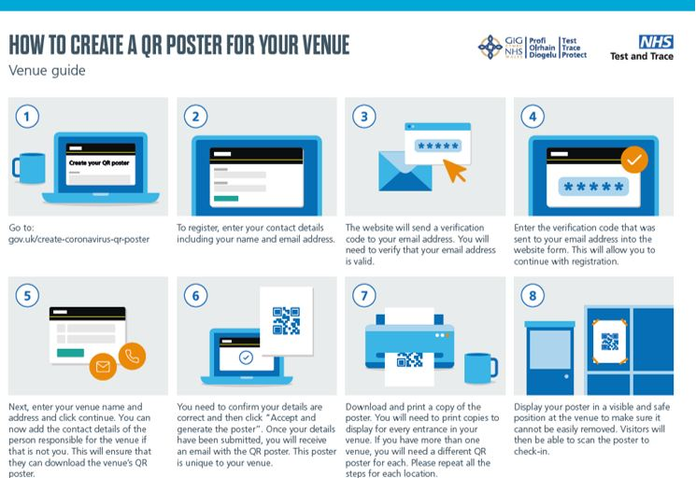
Firework displays cancelled
The Home Office has informed Local Authorities that they are cancelling all public firework displays for 2020.
We will be working closely with communities and businesses to try and reduce the impact this will have on communities and police demand for those who attempt to organise private events.
Advice for parents with concerns for children
We appreciate this might be a tricky time for parents with schools returning.
The council has prepared an easy to understand guide detailing what parents with a school age child can do.
The poster outlines to parents who maybe a bit confused on what steps to take if they or a household member displays symptoms of Covid-19.
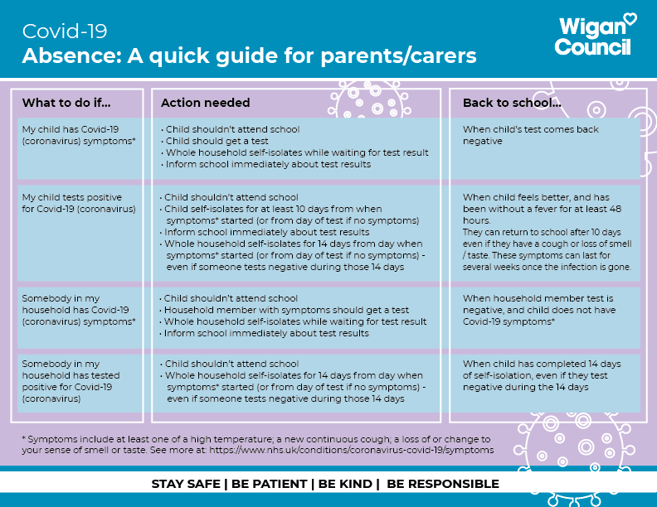

September 2020 news bulletin

We are continuing to bring you updates from Greater Manchester Combined Authority, the Mayor of Greater Manchester and Greater Manchester Fire and Rescue Service in a bid to keep the people of Greater Manchester informed and ensure they are receiving all of the right advice and guidance in relation to COVID-19. The organisation is continuing to support the city-region as we deal with the pandemic in a variety of ways.
The latest Government advice and guidance, including on how to protect yourself and others can be found on the Government's website.
You can also visit our website which has a dedicated COVID-19 page with a range of support and advice.
We always appreciate feedback, so if you have any suggestions about what you'd like to see in this newsletter, please email us: news@greatermanchester-ca.gov.uk.

We all need to do our bit to help stop the spread of COVID-19 in Greater Manchester. Find out more about how you can help on our website and from your local council.
Earlier this month a Living with Covid Resilience Plan was published - you can find out more about this on our website.

The latest of the weekly COVID-19 press conferences took place on Wednesday, September 16. The Mayor and local leaders have written to the Government with a proposal to work in partnership to introduce COVID escalation measures for the whole city-region. Read more about this on our website.

Greater Manchester receives grant to help unemployed
A programme designed to help newly unemployed people find work receives £13m funding boost from the DWP.

Latest blog and newsletter from Youth Task Force
Chair of the Youth Task Force, Diane Modahl, has shared her latest blog post. A newsletter has also been launched.

Switch to Digital Week taking place in October
We are running Switch Digital Week with Manchester Digital - a week-long event for people interested in exploring a career in digital and tech.

Professor Brian Cox to take part in GM Green Summit
The Mayor and Lily Rimmer (GMYCA) will be discussing the role of science in managing climate change at #GMGreenSummit.

Plan for homes, jobs and the environment
City-region leaders are to agree the updated timetable for the final stage of public consultation for the Greater Manchester Spatial Framework.

GMCA works with landlords to prevent evictions
Work is ongoing to prevent further homelessness in response to the ban on evictions, which is due to come to an end on September 20.

New Chief Fire Officer arrives in Greater Manchester
GMFRS has now welcomed Dave Russel, the former Deputy Chief in Lancashire, to its team. Dave took up his role on September 7.

Firefighters and a road victim share their 'stories'
A pedestrian who was hit by a speeding car joined GMFRS to raise awareness of the dangers that come with using the roads.

New chat function launched to help young people
On GCSE results day a new chat facility was launched on GMACS - Greater Manchester's careers and apprenticeship service.

Healthy Age Challenge Fund to help older people
A new project to develop pioneering age-friendly communities across Greater Manchester has been successful at the first stage of a bid.

70 apprenticeships created in Greater Manchester
The new apprenticeships have been created as part of the Removing Barriers initiative to help support underrepresented groups.

Charities in Greater Manchester receive funding
Charities helping prevent vulnerable young people getting involved in serious violence have been supported with Government grants.

Have your say
- APCC survey on enforcement and road safety - closes September 30
- State of the sector (VCSE) - closes September 25

Find out more about Greater Manchester Combined Authority
People often ask what GMCA is and what we do. More information about how the Combined Authority works, what our powers are and how we run can be found by clicking this link.

Our People, Our Place - the Greater Manchester Strategy
The Greater Manchester Strategy sets out our vision to make Greater Manchester one of the best places in the world to grow up, get on in life, and grow older. It's been written by all 10 councils, the Mayor, the NHS, transport, police and the fire service, with help from businesses, voluntary, community and social enterprise organisations, and members of the public. Find out more at www.greatermanchester-ca.gov.uk/ourpeopleourplace.

For all the latest news, as it happens, follow GMCA on Twitter and Facebook

GMCA News Bulletin September 2020
We're always keen for feedback, so if you've got ideas about how to make this bulletin better, please email us.
You can update your preferences on receiving this bulletin, or unsubscribe in the links below.

