Taking Care of the Environment KS2
With the weather warming up and days getting noticeably longer now is a great time to learn more about the environment and think carefully about the ways we can protect it. Here are some ‘Environmental’ activities that we think you will enjoy carrying out over the Easter break and into the new term. Included are some additional notes for some of the activities, including ‘All About Plastic Comprehension’, ‘Making a bird feeder’ and a Power Point from ‘BBC Teach: Live Lessons. Blue Planet’.
Go for a nature walk with your family. Can you spot any signs of spring? E.g. Daffodils, new life, freshly cut grass.
Draw pictures and write a list of what you have seen. 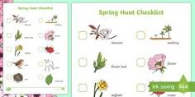

Design and create a sea creature using recycled materials.
Watch Power Point BBC Teach: Live Lessons. Blue Planet
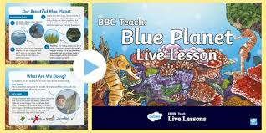
With the help of an adult, cut some fruit in half and draw the inside. 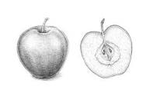

Make a bird feeder and draw pictures to record some of the birds that use it.
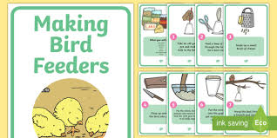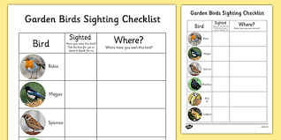
‘All About Plastic’ Comprehension
