Taking Care of the Environment KS1
With the weather warming up and days getting noticeably longer now is a great time to learn more about the environment and think carefully about the ways we can protect it. Here are some ‘Environmental’ activities that we think you will enjoy carrying out over the Easter break and into the new term. Included are some additional notes for some of the activities, including ‘Making a bird feeder’ and a recording sheet for a ‘Spring hunt checklist’.
Look through your recycling box at home. Can you make a model buiding?
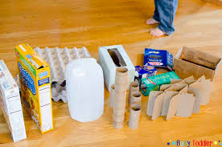
Go for a nature walk with your family. Can you spot any signs of spring? E.g. Daffodils, new life, freshly cut grass.
Draw pictures and write a list of what you have seen.
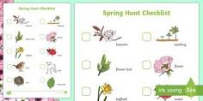

With the help of an adult, cut some fruit in half and draw the inside. 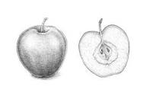

Make a bird feeder and draw pictures to record some of the birds that use it.
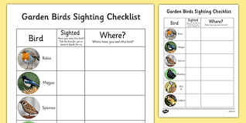
Write 6 things you do at home to help the environment.

