Lowton West
Primary School

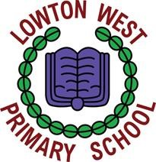

Remissions Policy

Policy reviewed by J. Westhead
Date policy reviewed: January 2024
Ratified by Governing Body:
Dr. G. Merrett (Chair of Governors)
Mrs J. Westhead (Headteacher)

Date adopted by the Governing Body: 25th January 2024

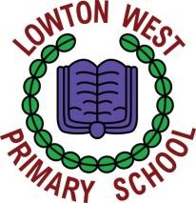
Lowton West Primary School Remissions Policy

Aiming High Together
School Vision
To inspire, achieve and succeed, we will aim high and build dreams and futures together.

Mission Statement
Providing the highest quality education, care and support for the whole school community.
Our mission statement is based on RESPECT:
R = Recognising the needs of the individual child
E = Ensuring a unique and engaging curriculum
S = Supporting each other to learn and achieve
P = Passionate about providing the highest quality education
E = Encouraging creativity, self – expression and imagination
C = Creating confident, resilient, life – long learners
T = The voice of everybody is heard
All the above statements help us to understand how we can all make a positive contribution to the school and the wider community.

We will do this through our core values:
- Respect
- Resilience
- Kindness
- Confidence

We also, at Lowton West Primary School, strive to develop and uphold British Values. The five British values that the Government has identified for schools to focus on are:

- Democracy
- The Rule of Law
- Individual liberty and mutual respect and tolerance of those with different faiths and beliefs
- Developing personal and social responsibility
- Respect for British Institutions

REMISSIONS POLICY IN CONNECTION WITH EDUCATION

At Lowton West Primary School

General

1.1. Section 457 of the Education Act 1996 requires that every governing body of a maintained school shall determine and keep under review a policy for remissions in connection with Education at that school.

1.2. This policy also reflects the advice issued to governing bodies, school leaders, school staff and local authorities by the DFE “Charging for School Activities” (Last updated May 2018).

1.3. This policy sets out the circumstances in which the governing body propose to remit (in whole or in part) any charge which would otherwise be payable to the governing body in accordance with the Charging Policy.

Remissions

2.1. There will be complete remission of any charges otherwise payable in respect of board and lodging provided for a pupil on a residential trip if the education provided on the trip is in respect of any visit that takes place during school hours; on any visit that takes place outside of school hours if it is part of the national curriculum or part of a syllabus for prescribed examination that the pupil is being prepared for at the school, or part of religious education and the parent of a pupil can prove that they are in receipt of certain state income benefits.

2.2. The parent of a pupil will be exempt from paying the cost of board and lodging if they are in receipt of the state income benefits at any time during the time spent on the trip.

